**Civics 1st Semester Quick Review Guide**

I should be able to:

**____SS.7.C.1.1 -** Recognize how Enlightenment ideas including Montesquieu’s view of separation of powers and John Locke’s theories related to natural law and how Locke’s social contract influenced the Founding Fathers.

**____SS.7.C.1.2 -** Trace the impact that the Magna Carta, English Bill of Rights, Mayflower Compact, and Thomas Paine’s Common Sense had on colonists’ views of government.

**____SS.7.C.1.3 -** Describe how English policies and responses to colonial concerns led to the writing of the Declaration of Independence.

**____SS.7.C.1.4 -** Analyze the ideas (natural rights, role of the government) and complaints set forth in the Declaration of Independence.

**____SS.7.C.1.5 -** Identify how the weakness of the Articles of Confederation led to the writing of the Constitution.

**____SS.7.C.1.6 -** Interpret the intentions of the Preamble of the Constitution.

**____SS.7.C.1.7 -** Describe how the Constitution limits the powers of government through separation of powers and checks and balances.

**____SS.7.C.1.8 -** Explain the viewpoints of the Federalists and the Anti-Federalists regarding the ratification of the Constitution and inclusion of a bill of rights.

**____SS.7.C.1.9 -** Define the rule of law and recognize its influence on the development of the American legal, political, and governmental systems.

**___SS.7.C.2.1 -** Define the term “citizen,” and identify legal means of becoming a U.S. citizen.

**___SS.7.C.2.2 -** Evaluate the obligations citizens have to obey laws, pay taxes, defend the nation, and serve on juries.

**___SS.7.C.2.4 -** Evaluate rights contained in the Bill of Rights and other amendments to the Constitution.

**___SS.7.C.2.5 -** Distinguish how the Constitution safeguards and limits individual rights.

**___SS.7.C.3.6 -** Evaluate constitutional rights and their impact on individuals and society.

**___SS.7.C.3.1-**Compare different forms of government (direct democracy, representative democracy, socialism, communism, monarchy, oligarchy, autocracy).

**___SS.7.C.3.2 -**Compare parliamentary, federal, confederal, and unitary systems of government.

**___SS.7.C.3.3 -**Illustrate the structure and function (three branches of government established in Articles I, II, and III with corresponding powers) of government in the United States as established in the Constitution.

**___SS.7.C.3.5 -** Explain the constitutional amendment process.

**C.1.1 ENLIGHTENMENT THINKERS**

Enlightenment Thinkers such as **John Locke** and **Baron de Montesquieu** influenced the founding fathers when writing the Declaration of Independence and the US Constitution.

***Essential Question: What are the ideas of the Enlightenment Thinkers that influenced the Founding Fathers in shaping the American Government?***

**John Locke** - ideas of natural rights, consent of the government and social contract are evident in the Declaration of Independence.

**Baron de Montesquieu** - idea of checks and balances and separation of powers are evident in the US Constitution.

**C.1.2 INFLUENCE OF EARLY DOCUMENTS**

**American constitutional government is founded on concepts articulated in earlier documents.**

***Essential Question: What are the early documents that helped shape the American Government?***

|  |  |  |  |
| --- | --- | --- | --- |
| The English Bill of Rights | The Magna Carta | Mayflower Compact | Common Sense |
| The English Bill of Rights expanded the powers of the English Parliament and expanded the rights of the people, as well as further limited the rights of the king.  **Limited Government**  **Rights**  **Rule of Law** | The Magna Carta limited the power of the king of England and protected the rights of the nobility.  **Rule of Law**  **Limited Government**  **Rights** | The Mayflower Compact was an agreement written by English Puritans on way to America. It provided order and protected the rights of the colonists.  **Self Government**  **Rights**  **Rule of Law** | A pamphlet written by Thomas Paine in clear, easy to understand language. Urged colonists to support becoming independent from England.  **Self Government**  **Rights** |

**SIGNIFICANT DOCUMENTS DEFINING AMERICA**

***Essential Question: What are the early documents defining America as an independent nation?***

C.1.4 The **Declaration of Independence**

– stated grievances **against the king** of Great Britain

(taxation, representation and rights)

– declared the colonies’ **independence** from Great Britain

– affirmed “**certain unalienable rights**” (life, liberty, and the pursuit of happiness) established the idea that all people are **equal under the law**.

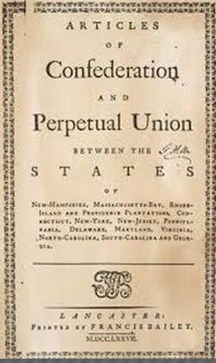C.1.5 The **Articles of Confederation**

– established the first form of **national government** for the independent states

– maintained that major **powers** resided with **individual states**

– created **weak central government** (e.g., no power to tax or enforce laws); led to the writing of the **Constitution** of the United States of America.



**C.1.6 The Preamble to the Constitution**

Sets forth the **goals and purposes** to be served by the government. Expresses the reasons the constitution was written. It begins with "We the People" establishing that the power of the government comes from the people.

***Essential Question: What are the purposes identified in the Preamble?***

1. To form a more **perfect union (unite the nation, create a better government)**
2. To establish **justice (a system that is fair to all)**
3. To ensure **domestic tranquility (peace in the country)**
4. To provide for the **common defense (protect us from enemies)**
5. To promote the general **welfare (provide for the well-being)**
6. To secure the blessings of **liberty (protect freedoms for future generations)**

**C.1.7 THE CONSTITUTION OF THE UNITED STATES OF AMERICA**

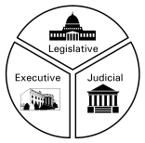

***Essential Question: How does the United States Constitution limit the powers of the government?***

The **Constitution** of the United States of America established the **structure** of the United States government and limited the power of each branch with **checks and balances and separation of powers.**

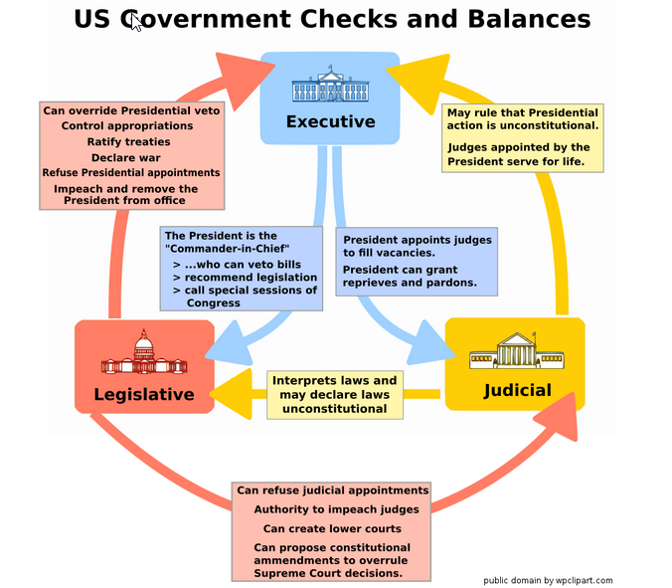

**C.1.8 FEDERALIST AND ANTI-FEDERALIST**

***Essential Question - How did the Federalist and Anti Federalist differ? How did they reach an agreement on the ratification of the Constitution?***

**Anti-Federalist - opposed** the ratification of the Constitution. They did not want a powerful central government. They did not want the states to lose any power.

* + The Constitution gave too much power to the national government
  + The legislative and executive branches were too powerful
  + The Constitution lacked a specific listing of rights to protect the people

**Federalists - supported** the ratification of the Constitution. They wanted a strong central government that would share power with the states.

* The Constitution is necessary in order to protect the liberty and independence gained from the American Revolution
* Specifically listing of rights wasn't necessary because the Constitution itself protected the rights of the people because of separation of powers

**Compromise -** Adding a **Bill of Rights**

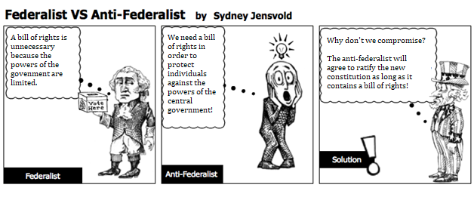

**C.1.9 THE RULE OF LAW**

***Essential Question - How does the Rule of Law protect individual rights?***

1. A formal process of law enforcement. Due Process.

2. No one is above the law and everyone must follow the law.

3. To protect citizens. (Rights of the accused - 4th, 5th, 6th, 8th amendments)

Rule of law binds all people and is enforced by a system of courts and law enforcement.

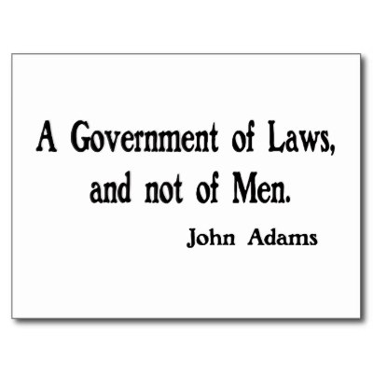

In order to secure equal rights to all citizens, government must apply law fairly and equally through this legal process. Notice, hearings, indictment, trial by jury, legal counsel, the right against self-incrimination—these are all part of a fair and equitable “due process of law” that provides regular procedural protections and safeguards against abuse by government authority.

**C.2.1 THE PROCESSES BY WHICH AN INDIVIDUAL BECOMES A CITIZEN OF THE UNITED STATES.**

A **citizen** is an individual with certain rights and duties under a government and who, by birth or by choice, owes allegiance to that government.

***Essential Question: How does an individual become a citizen?***

The **Fourteenth Amendment** to the Constitution of the United States of America **defines citizenship** as follows:



“All persons **born or naturalized** in the United States, and subject to the jurisdiction thereof, are citizens of the United States and the state wherein they reside.”

Means of **obtaining citizenship**

* By **birth - law of blood/law of soil**

* By **naturalization**

**Immigration** and **naturalization**, particularly in the twentieth century, have led to an increasingly **diverse society**.

To become a citizen through **naturalization**, a person must demonstrate **knowledge of American history** and principles and the ability to read, speak, and write words in ordinary usage in the **English language.** In order to be naturalized, an applicant must first be qualified to apply for citizenship. Then, he or she must **complete an application**, **attend an interview, and pass an English and a civics test**. Upon successful completion of these steps, the applicant **takes an oath of loyalty**, and becomes a citizen.



**C.2.2 CITIZENSHIP’S RIGHTS & DUTIES**

**First Amendment freedoms of religion, speech, press, assembly, and petition, and the rights guaranteed by due process and equal protection of the laws.**

The Constitution of the United States of America establishes and protects the citizens’ **fundamental rights and liberties.** Few rights, if any, are considered **absolute**.

***ESSENTIAL QUESTION? What fundamental rights and liberties are guaranteed in the First and Fourteenth Amendments to the Constitution of the United States of America?***

**First Amendment freedoms**

* **Religion:** Government may not establish an official religion, endorse an official religion, or unduly interfere with the **free exercise of religion.**
* **Speech:** Individuals are free to express their opinions and beliefs.
* **Press:** The press has the right to gather and publish information, including that

which criticizes the government.

* **Assembly:** Individuals may peacefully gather.
* **Petition:** Individuals have the right to make their views known to public officials.

**DUTIES OF CITIZENSHIP**

For government to be effective, citizens must fulfill their civic duties.

***ESSENTIAL QUESTION: What civic duties are expected of all citizens?***

**Duties** of citizens

* Obey **laws**
* Pay **taxes**
* Serve in the **armed forces**, if called
* Serve on a **jury** or as a witness in court, when summoned

Citizens who choose not to fulfill these civic duties face **legal consequences.**

**RESPONSIBILITIES OF CITIZENSHIP**

A basic **responsibility** of citizenship is to contribute to the **common good.**

***ESSENTIAL QUESTION: What are the ways individuals demonstrate responsible citizenship?***

**Civic responsibilities** are fulfilled **by choice**; they are v**oluntary.**

**Responsibilities of citizens**

* Register and **vote**
* Hold **elective office**
* **Communicate** with government officials to influence government actions
* Serve in **voluntary,** appointed government positions
* Participate in **political campaigns**.
* Keep informed regarding **current issues**
* **Respect others’** right to an equal voice in government

**C.2.2 Continued COMMUNITY NEEDS**

**Civic and social duties address community needs and serve the public good.**

A **democratic society** requires the active **participation** of its citizens.

***ESSENTIAL QUESTION: In what ways do citizens participate in community service?***

**Ways for citizens to participate in community service**

* **Volunteer** to support democratic institutions (e.g., League of Women Voters).
* **Express concern** about the welfare of the community as a whole (e.g., as related to environment, public health and safety, education).
* **Help** to make the community a good place to work and live (e.g., by becoming involved with public service organizations, tutoring, volunteering in nursing homes).

**GOOD CITIZENSHIP**

Thoughtful and effective **participation** in civic life depends upon the exercise of **good citizenship**.

***ESSENTIAL QUESTION: How do individuals demonstrate thoughtful and effective participation in civic life?***

**Elements of good citizenship**

* **Trustworthiness** and honesty
* **Courtesy** and **respect** for the rights of others
* **Responsibility**, accountability, and self-reliance
* Respect for the law
* **Patriotism**
* **Participation** in the school and/or local community
* **Participation** in **elections** as an informed voter

**C.2.4 - The Bill of Rights**

**C.3.6 - Constitutional rights and their impact on individuals and society.**

***Essential Question: What rights are protected in the Bill of Rights?***

*Bill of Rights*

**1st Amendment:** Freedom of speech, press, religion, petition, and assembly (RAPPS)

**2nd Amendment:** Right to bear arms (owning of Guns)

**3rd Amendment:** NoQuartering of Soldiers

**\*4th Amendment:** Privacy Act (search warrant) protection against of illegal search and seizures

**\*5th Amendment:** self-incrimination, due process of law, grand jury, eminent domain, and double jeopardy

**\*6th Amendment:** speedy and public trial, right to attorney

**7th Amendment**: Civil Cases

**\*8th Amendment:** Protection against cruel and unusual punishment; excessive bail

**9th Amendment:** unmentioned rights (we still have them even if they aren't mentioned in the Constitution)

**10th Amendment:** Reserved Powers to the states e.g. marriage, education, divorce, professional certification

* Rights of the accused

**C.2.5 Constitution Safeguards and Limits Rights**

***Essential Question: How does the Constitution protect and limit rights?***

In Article 1, Section 9 of the U.S. Constitution, there are three key individual rights that are protected, or safeguarded:

* **Writ of Habeas Corpus** - court must prove why they are holding someone
* **No Bill of Attainder** - written to punish one or a small group of people
* **No Ex Post Facto Law** - makes an act a crime ***after*** it has been committed

**Individual rights are protected but they are not unlimited**.

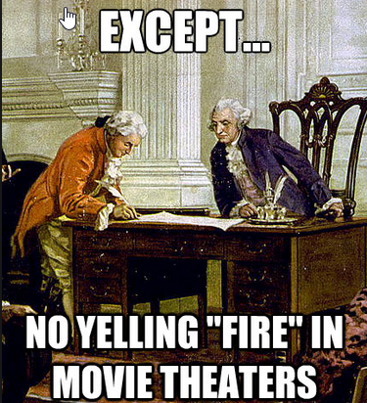In the Supreme Court case *Schenck v. U.S.* in 1919, the court created the “balancing test.” The balancing test focuses on individual rights and the public interest and allows rights to be restricted, or limited, when the public interest in threatened.

Listed below are additional criteria used to limit freedom of speech and freedom of the press.

1. **Clear and Present Danger** – Will this act of speech create a dangerous situation?
2. **Fighting Words** – Will this act of speech create a violent situation?
3. **Libel** – Is this information false or does it put true information in a context that makes it look misleading?
4. **Obscene Material** – Is this material inappropriate for adults and children to see in public?
5. **Conflict with Government Interests** – During times of war the government may limit speech due to national security.

**C.3.1 and C.3.2 Forms and Systems of Government**

|  |  |
| --- | --- |
| **Type of Gvt** | **Description** |
| Direct Democracy | a form of government in which the power to govern lies directly in the hands of the people rather than through elected representatives |
| Representative Democracy | a system of government in which the people elect representatives to make policies and laws for them, **also known as a republic** |
| Constitutional  Monarchy | a form of government headed by a king or queen who inherits the position, rules for life, and holds limited power |
| Autocracy | a form of government where one person has unlimited power |
| Absolute Monarchy | a form of government headed by a king or queen who inherits the position, rules for life, and holds absolute power |
| Dictatorship | a form of autocracy where a military leader becomes the leader of a country often through violent means |
| Oligarchy | a form of government in which a small group has total control and power |
| Federal System | Power is shared by a by a powerful central government and the states |
| Confederal | Power is mostly with the states that are joined together in a weak organization. Central government has limited power. |
| Unitary | One strong central government with little or no power shared with the states. |
| Parliamentary | A form of democracy but people vote for a political party and not a candidate. Parliament selects the Prime Minister. |

C.3.3 Structure and Function of the Government

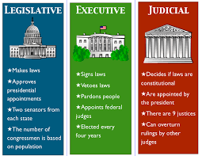

C.3.5 Amending the Constitution

*How can the* ***Constitution of the United States*** *be* ***amended****?*

The amendment process is **complex**. The framers made it difficult because the amendments are part of the Constitution and affect all of us. They did not want unnecessary changes added to the Constitution. Both the federal government and the states are involved in the amendment process but it is only handled in the Legislative branch of government.

1. To date, there are **27 amendments** to the Constitution of the United States.
2. **Amendment process:**
4. Two step process. Propose and Ratify.
5. **Proposal: 2/3 of Senate and 2/3 of House must approve the proposal**
6. **Ratification: 3/4 of the States Legislatures must ratify the proposed amendment**