SS.7.C.2.14
Conduct a service project to further the public good. 3 hour minimum requirement with a reflective essay, supervisor signoff and photos.

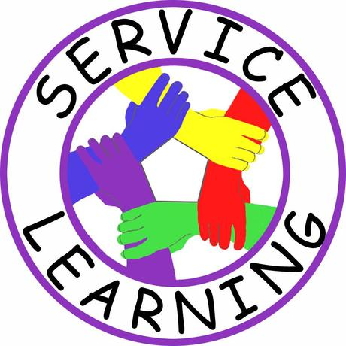
Possible Service Learning Ideas
- Spend time reading or playing games with residents at a senior home
- Help build a house with Habitat for Humanity
- Clean up a local, state or national park (Jennings State Forest Earth Day Clean Up)
- Organize or assist with a food drive for a local food bank
- Participate in a Keep Clay Beautiful road clean up or Keep Clean Earth events
- Assist with Clay County Historical Society events
- Read to elementary school students
- Assist teachers before or after school hours at LAJH or other schools
- Lend a hand in a political campaign
- Assist with recreational activities at a local park
- Prepare and distribute meals at the local shelter
- Work concessions at a school sports’ event
- Organize a collection drive for a local charity
- Assist at the Special Olympics (competition for those with disabilities)
- Tutor your peers or younger students
- Deliver meals to homebound seniors (Meals on Wheels)
- Assist at St. Johns River keeper events
- Assist in your religious institution’s nursery
- Build something that could be used by a local group.
- Organize a fundraiser for a local charity.
- Volunteer for Teen Court Program
Student Service Learning
Alternative Assignment

In lieu of completing the required three hours of service learning, the assignment described below will count as your service learning for first semester. You will be researching an international volunteerism organization.

Details:
- Title Page (title of paper, your name, date, & class period)
- 1000 Word Minimum (include a word count at the bottom of the last page)
- Double-spaced, 12 point font, Times New Roman.
- MUST include a print out of Organization/Agency’s Website
- MUST include a bibliography with at least 5 sources.
Example of a single source on a bibliography:
Source Info. Infro.
“Hispanic Serving Institutions (HSI) Grant Project.” California State University, Northridge Oviatt Library. February 2, 2005. Web. 7 February 2008 <http://library.csun.edu/hsi/ >.

Organization:
- Introduction Paragraph – Introduction to the information contained in the essay, what is the reader to expect?

- Paragraph 2-3: This paragraph should outline the history/origin of the organization or agency you’ve selected to research. Remember – use your own words. DO NOT COPY & PASTE.

- Paragraph 3-4: These paragraphs should detail the purpose of the organization or agency that you’ve selected to research. What do they do? Who do they service? What’s the impact?

- Paragraph 5: This paragraph should describe the location and contact information for the agency. Are they located in one country or in several countries? How would someone get in touch with them to join?

- Paragraph 6: This paragraph should explain how this organization or agency is funded. Do they receive grants or donations? Does that countries government provide financial support? Who (what Groups) are in support of this organization/agency?

- Final Paragraph: This paragraph should list the reason why you selected this organization or agency to research. What interested you about them? How did you hear about them? What have you learned about this organization and the services that they provide? Etc.

Service Learning Plan
D*Do not begin work until your plan has been approved.*

Student Name: ___________________________________________________ Period _______

I will not be completing the 3 hour community service option. I will complete the alternate assignment.
I will be completing the 3 hour community service option. If this box is checked, complete the following:
Place Service Learning will be completed: ___________________________________________
Address: ______________________________________________________________________
Internet Web Address: ___________________________________________________________
Contact Name (volunteer supervisor): _______________________________________________
Contact Phone Number: __________________________________________________________
List the type of work you will be doing:______________________________________________
______________________________________________________________________________
______________________________________________________________________________
______________________________________________________________________________
______________________________________________________________________________
______________________________________________________________________________

Student Signature _______________________________________Date___________________
Parent Signature ________________________________________ Date___________________
Teacher Approval to Begin: __________________________________ (obtain by October 6th)

I. Supervisor Rating Sheet

Service Learning Project
(Take this paper to your service site for signatures and turn in with project)

===========================================================

Place Service Hours Were Completed: _____________________________________

Dates & Times Worked (list each date and time separately): ____________________________________________________________________
____________________________________________________________________
____________________________________________________________________
Total Hours Spent Providing Service: ____________________

Service Learning Supervisor Rating (must be completed after service)
---------------------------------------------------------------------------------------------------------------------
Supervisor’s/Contact’s Name (print):________________________________________
Supervisor’s/Contact’s Phone #:____________________________________________
Supervisor’s/Contact’s Signature:_______________________________________________ (indicates that a minimum of 3 hours of volunteering were completed)
Supervisor’s/Contact’s Rating of Volunteer:
1. Was the volunteer on time? YES NO
2. Was the volunteer friendly and polite to those they served? YES NO
3. Please rate the student volunteer on a scale of 1 to 5 (1 =poor , 5 = exemplary) _____
Comments: (optional)

II. Reflective Essay: (2 pages double spaced 12 point Font)
Please describe your service learning experience. Be sure you respond to each of the following questions in your essay.
What type of work did you do?
Why did you choose this?
What group was your work intended to impact?
Do you think you did, and if so, how can you tell?
If not, what do you think you could have done differently?
Finally, what lesson(s) did you learn from this experience?

III. Service Learning Photographs

Please remember to take at least three photos of you while volunteering. These photos need to clearly demonstrate you at work.

IV. Rubric

Rubric must be attached to your project when submitted/presented.
You will either have a peer review your project prior to submitting, or you may review and grade your own project. Your teacher will be the final authority on your completed project.

Criteria | Outstanding | Good | Fair | Poor
Supervisor Evaluation | Completed and attached with supervisor signature and evaluation  10 | Supervisor signature found on additional form or letter  7 | NA  0 | Not completed and/or attached  0
Quality of Reflection  1. What type of work did you do?  2. Why did you choose this?  3. What group was your work intended to impact?  4. Do you think you did, and how can you tell?  5. How could you have improved your service work?  6. What lesson(s) did you learn from this experience? | All questions fully addressed with details and examples  60 | All questions addressed with some detail  50 | Questions addressed with minimum detail  40 | Three or fewer questions addressed in the essay  30
Presentation | No spelling or grammar issues; typed or written in black ink  10 | Fewer than three spelling or grammar issues; typed or written in black ink  7 | Some spelling and grammatical issues  5 | Spelling and grammar issues throughout essay  2
Photos | At least three color photos featuring student completing work; includes captions in black ink  20 | At least three photos featuring student completing work in black and white; includes captions  14 | Fewer than three photos OR at least three photos do not feature student OR photos do not contain captions  10 | No Photos  0
Totals

Service Learning Rubric

