Study Guide: Civics EOC Exam
- John Locke: What ideas is he known for?
- The Social Contract
- Natural Laws / Rights: Government protects “life, liberty, and property.”
- Influenced the Declaration of Independence

- What is the social contract? People gave away power to rule & some rights, but get back protection from the government

- Montesquieu: How did he influence the “Founding Fathers?”
- Separation of Powers: three branches
- Checks and Balances

- What are four concepts found in the Magna Carta that influenced the Founding Fathers?

- Limited government
- Trial by jury
- Advisors lead to Parliament
- Rule of Law

- List three rights that are found in the English Bill of Rights that are found in the US Bill of Rights:
- Freedom of Speech
- No cruel and unusual punishment
- No taxes w/o consent

- Name three concepts in the Mayflower Compact that influenced the Founding Fathers:
- Self-government
- The rule of law
- Social Contract
- What did Thomas Paine's Common Sense influence the Founding Fathers to do? “Common Sense” to declare independence from Great Britain. Influenced Declaration of Independence

- List three things that the British did that made the Colonists angry?
- Stamp Act
- Quartering Act, Tea Act
- No taxation w/o representation

- Who was the "Grievances" of the Declaration of Independence addressed to? King George III

- What rights did Thomas Jefferson say every American is entitled to in the Declaration of Independence? Life, liberty, and the pursuit of happiness

- Which Enlightenment philosopher influenced Jefferson in the "Natural Rights" section of the Declaration of Independence? John Locke

- List three weaknesses of the Articles of Confederation:
- One branch: no judicial or executive branch
- No power to tax, regulate trade or enforce laws
- Too rigid: 9 out 13 states to pass laws, 13 out of 13 to pass amendments

- List the goals of the Preamble and describe what they mean:
“We the people” – popular sovereignty the people are the source of government power
“A more perfect union” – to make a better country and a stronger government than under the Articles of Confederation
“Establish justice” – fairness/equality, represented by our court system
“Ensure domestic tranquility” – keep the peace inside the country – usually the police
“Provide the common defense” – keep the country safe from other countries, the military
“Promote the general welfare” – help people
“Secure the blessings of liberty” – provide freedom
“To ourselves and our posterity” – rights and freedom for now and the future
- Define Separation of Power: divide power into three branches
- Define Checks and Balances: Each branch checks the power of the others
- Provide an Example of Checks and Balances for each branch:
- President vetoes a law
- Congress can impeach the president or justices/judges
- Supreme Court / Federal judges can declare laws unconstitutional
- Define the Rule of Law: Nobody is above the law, leaders must follow the law, protects citizens from tyranny & abuse of power
- What President demonstrated the Rule of Law: Richard Nixon
- List two “sources” of American Law:
- Code of Hammurabi
- English Common Law
- List four “types” of law:
- Civil
- Criminal
- Constitutional
- Military
- Which Amendment defined citizenship? 14th
- List five “qualifications” for becoming a naturalized citizen:
- Must by 18 years old
- Be a lawful permanent resident
- Have lived in the US for five years
- Be of “good moral character.”
- Know basic English by passing a Civics/US History test

- What are the two ways to become a natural born citizen? Law of Soil – born on US soil, Law of Blood – born to US citizens abroad

- List the six steps to becoming a naturalized citizen:
- Live in the US for five years
- Fill out an application
- Fingerprint / background check
- Interview
- pass the Civics & English test
- Take the Oath of Allegiance
- List four “obligations (duties)” of US citizens:
- Obey the Law
- Pay taxes
- Serve on Juries
- Defend the nation
- List four “responsibilities” of citizenship:
- Vote
- Attend civic meetings
- Petition the government
- Run for office
- List the 10 Amendments in the Bill of Rights:
- Freedom of speech, religion, petition, assembly, and the press
- The Right to Bear Arms
- No quartering of soldiers
- No unreasonable search or seizure
- Rights to remain silent, due process
- Right to a lawyer, jury, to confront one’s accuser, and a speedy and public trial,
- Right to a jury in civil trials
- No cruel and unusual punishment
- Rights not listed in the Bill of Rights belong to the people
- Powers not listed in the Constitution belong to the states
- Define the following Amendments:
13th: No slavery
14th: Define citizenship, equal protection under the law, state laws must be constitutional
15th: Right to vote for African-American men
19th: Right to vote for women
24th: Abolished poll taxes
26th: Lowered the voting age from 21 to 18
- List the outcomes of the following Landmark Supreme Court Cases:
- Marbury v. Madison Established judicial review
- Plessy v. Ferguson: the “separate but equal” case which legalized segregation
- Brown v. Board of Education: overturned Plessy vs. Ferguson and ended legal segregation
- Gideon v. Wainright: If a person can’t afford a lawyer, one must be provided by the state
- Miranda v. Arizona: 5th Amendment righto remain silent, 6th Amendment right to a lawyer, must be notified of rights
- In re’ Gault: juveniles have due process rights to a lawyer and to confront accusers
- Tinker v. Des Moines: students have free speech rights, and free speech is more than just words: freedom of expression
- Hazelwood v. Kuhlmeier: Limited student’s free speech rights
- US v. Nixon: Rule of Law – even the president, is not above the law
- Bush v. Gore: Controversial case where Supreme Court ordered a stop to the recount of the 2000 presidential election
- Describe the following Political Parties:
    - Democrats: - Government welfare programs to help those in need, Higher taxes, Business regulations
    - Republicans: - Less federal government programs, Lower taxes, Fewer business regulations
- Libertarians:- Maximum freedom and rights, minimum government
- Socialist: - Governments control some businesses, free education and welfare programs
- Communists: - Workers and the people would control businesses, most were dictatorships

- List the Constitutional Qualifications for the following offices:
President:
- 35 years old, resident for 14 years
- “natural born” citizen

House of Representatives:
- 25 years old
- a resident of the state and a citizen for seven years

Senate:
- 30 years old
- a resident of the state and a citizen for nine years

- Define Party Platform: Statement outlining the main goals & ideas of the party
- Define Political Action Committee: Organization to raise money for candidates or issues to get around fundraising limits
- Define Bias: opinionated, one-sided information
- Define Media Watching Role: Media watches the government to ensure they don’t break the law
- Define Propaganda: Biased information meant to persuade public opinion
- Define Public Policy: government plan to resolve issues or problems
- List 3 things each level of government is responsible for:
- FEDERAL - Military, interstate & foreign trade, environmental issues, interstate health care
- STATE - Education, intrastate trade, intrastate environmental and safety
- LOCAL - Local schools, local roads, local sanitation & services, local safety
- What is a “domestic policy”? Plan to deal with problems inside the country
- What is a “foreign policy”? Treaties, foreign trade, the military
- List the ways the President deals with foreign policy:
  - Signs treaties
  - Appoints ambassadors
  - Appoints Secretary of State
  - Serves as Commander-in-Cheif
  - Chief diplomat
- List the ways Congress deals with foreign policy:
  - Confirms treaties (Senate)
  - Declares war
  - Provides funding for wars or foreign policy
  - Confirms ambassadors and secretary of state (Senate)
Define the following international organizations:
- United Nations: Organization for nations to gather to discuss issues and work towards world peace
- NATO: Defensive treaty between the US, Canada, and Europe
- NAFTA: North American Trade Oranization, Canada, the U.S. & Mexico free trade agreement
- UNICEF: U.N.’s organization for helping children
- International Court of Justice (World Court): Court for settling international disputes and hold war crimes trials
- WTO International organization devoted to free trade
- Red Cross: Neutral organization that provides emergency aid during wars or emergencies
- NGOs: Non-governmental organizations that provide aid
- What two wars fought in Europe and Asia where the last “declared wars”? World War I & II
- Name two “undeclared” wars? Vietnam, Korea, Afghanistan, Iraq
- What was the decades long conflict between the United States and the Soviet Union referred to? The Cold War
- What were the two conflicts with Cuba in the 1960s? The Bay of Pigs and Cuban Missile Crisis
- What country were the two “Gulf Wars” fought against? Iraq
- Define the following “forms” of government:
- Direct Democracy: All citizens vote on laws
- Representative Democracy: The people vote for representatives who make laws and make decisions for them
- Absolute Monarchy: King or queen has absolute power
- Constitutional Monarchy: King or queen mostly ceremonial
- Communism: All private property and companies are owned/controlled by the government
- Socialism: Public ownership of certain businesses, large welfare programs
- Autocracy: Rule by one
- Oligarchy: Rule by a few
- What “system” of government is power shared between the national and regional governments? Federal or Federalism
- What system of government do the regional governments tell the central government what to do? Confederation or confederal
- What system of government does the central government have all of the power? Unitary
- Who is the executive chosen by in a Parliamentary System? Parliament or legislative body
- What are powers held by the national government called? Expressed, enumerated or delegated
- List ten constitutional powers of the national government: Tax, regulate commerce, coin money, approve presidential appointments, impeachment, raise and support the army & navy, declare war, create rules for naturalization and immigration, confirm treaties, make all laws necessary and proper
- List the three levels of Federal Courts: District, Court of Appeals, U.S. Supreme Court
- List the three levels of the Florida Court System: County/Circuit Courts, District Court of Appeals, Florida Supreme Court
- What are powers shared by the national and state governments called? Concurrent
- List three powers shared by the national & state governments: Tax, create courts, borrow money
- What are powers held by state governments called: reserved powers
- List three powers held only by state governments: Establish local governments, intrastate trade, elections, marriage, licences
- What do you call the system in which powers are shared by national and state governments? Federalism
- How are federal amendments made? 2/3rds of the Congress, 3/4ths of the states
- List the Steps through Congress for passing a law:
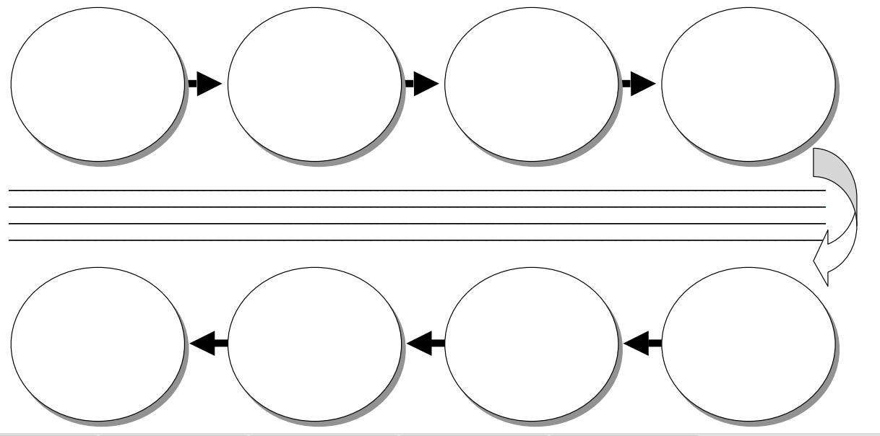
Sent to the executive
Conference committee
Floor debate & vote
Sent to committee for debate & vote
Sent to the other house
Floor debate & vote
Committee debate and vote
Introduce bill

- Complete the Chart Comparing the US & Florida Constitutions:
United States Florida
Articles: 7 | Articles: 12
Size: 1 page | Size: 80 pages
Rights Contained in: Bill of Rights | Rights Contained in: Declarations of Rights
Shorter, begins with “We the People”, living document to be interpreted over time, 27 Amendments | Specifics: longer, begins with “We the People”, many amendments, more specifics, deals with day-to-day aspects of life,

- List three ways to amend the Florida Constitution
- Proposed and voted by state legislature, needs 3/5ths vote
- Constitutional Commission that meets every 20 years
- Petition signed by 8% of electorate, put on ballot, ratified by 60% vote of electorate

- List Services Provided by each level of government:
- National: Disaster relief, environment, food & drug safety, welfare programs, postal service, interstate highways
- State: Education, environment, licenses, state highways, state police, public safety
- Local: local police, fire department, libraries, schools, local roads, trash collection

